**GIT CONFIGURATION & USAGE**

Git is a version control system that is used by web-based platform GitHub to assist developers in sharing and managing their code. It offers a cooperative setting where numerous users can track changes over time, collaborate on projects, and contribute to open-source projects. Here's a brief overview:

Git: What Is It?  
Linus Torvalds developed the distributed version control system known as Git in 2005. It makes it possible for several developers to collaborate on a project at the same time without interfering with one another's work. It keeps track of all the changes made to the codebase, archives these changes, and assists in resolving conflicts that may occur when separate code versions are combined.

GitHub: What is it?  
Git repositories can be hosted by GitHub. It gives Git a web-based interface, which facilitates repository management, teamwork, and code sharing. In addition to being popular for open-source projects, GitHub allows users to host private repositories for businesses or individuals.

Step 1: Using command “sudo zypper install git” to install the git

Figure 1

Step 2: Using command “git --version” to check the version of git to ensure that is latest version.

Figure 2

Step 3: Click create repository to create a new repository.

Figure 3

Figure 4

Step 4: Create a folder for GitHub, then right click that and run on terminal.

Figure 5

Step 6: Using command “git clone https link” to import repository to your OS.

Figure 6

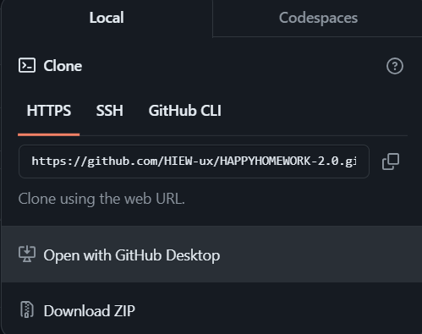

Figure 7

Step 8: Using command “ls” to check the files in folder, and using command “touch file_name” to create a file.

Figure 8

Step 9: Insert some coding in the file you create.

Figure 9

Step 10: Using command “git add file_name” to place the file in staging area before commit. After that using command “git status” to check if the file can be uploaded or not. (red means cannot, green means can)

Figure 10

Step 11: Using command git commit -m “comment” to save the file in repository.

Figure 11

Step 12: Go to GitHub website and then select settings, then click Developer settings. Then choose Token (classic) to build a token.

Figure 12

Figure 13

Figure 14: Name your token then adjust expiration time, then select all the scope.

Figure 15

Step 13: Using command “git remote set-url origin <https://Token_link@github.com/repository_link>” to manage the repository. Then using command “git push origin main” to allow that you can see your file in GitHub.

Figure 16

Figure 17

Figure 18